Software Review

Calvin Moylan

30018702

2020

# Contents

Software Review Plan 2

Software Review 2

Performance 2

UI Design 3

Security 5

Client Requirements 6

Conclusion 8

# Software Review Plan

A plan for reviewing this week’s software product must be conducted to ensure the requirements of the client has been met and to ensure that they will be satisfied with the end product. Below is outlined what the new website feature set will compared against. These must be in line with the CITE Managed Services QA.

I will make sure that the requirements of the product has been met by performing a review of the finished software by comparing it against the performance of the website, the UI design, security and the feature requirements set by the client.

## Software Review

### Performance

The performance of the website must be quick. Users will not want to spend their time waiting for a webpage to load. Luckily for us, this website does not use any hardware intensity code just as JavaScript so all the user’s web browser has to do is render the HTML sent by the server. The user sign up and admin portal all happen on the server side so the user does not have to worry about having to wait long periods of time for their browser to handle it. Having the server handle all sensitive requests is also makes the website secure.

The website was originally written by Calvin which was then improved upon by Panashe during the second week of sprints.

Here is a list of performance stats:  
Index Page: 0.0002 seconds  
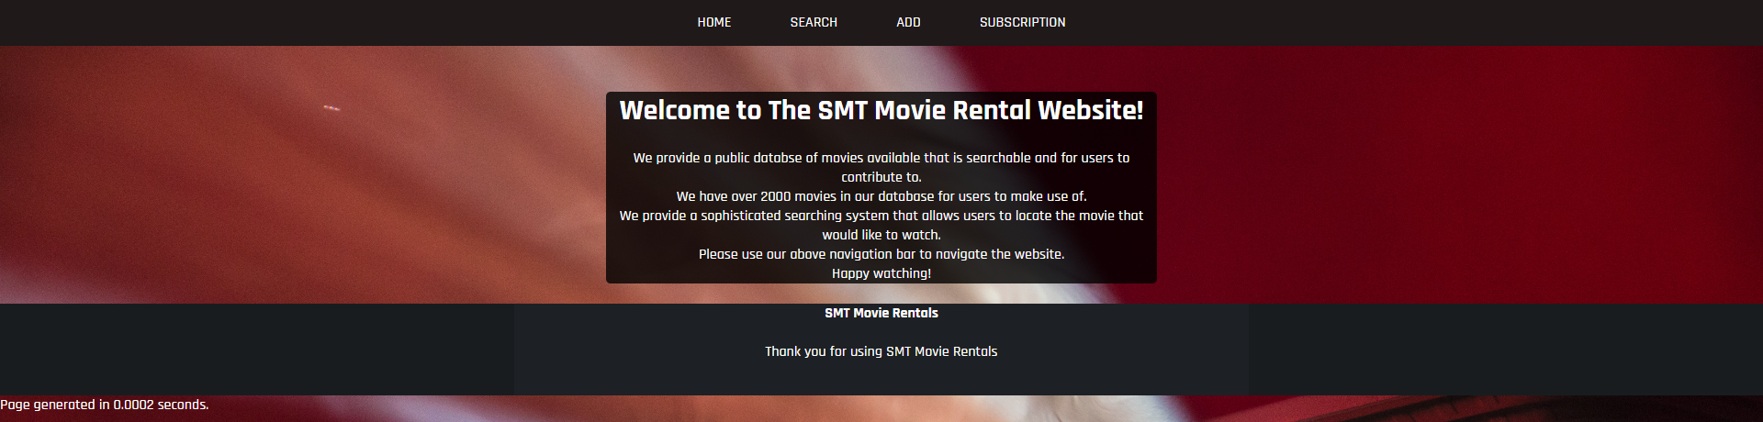

Searching for all movies: 0.0432 seconds  
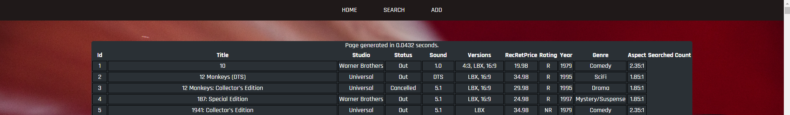

Admin Page: 0.0359 seconds  
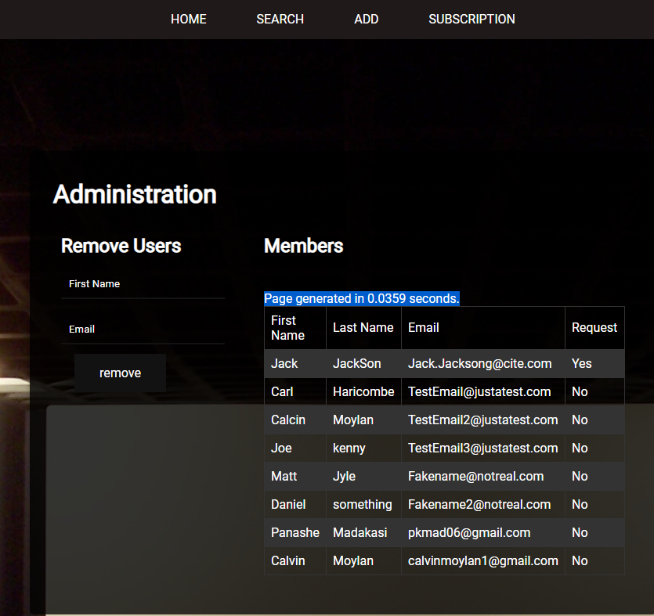

### UI Design

The UI Design must be simplistic and easy to navigate. We went about this by having one ribbon navigation bar across the top of the screen which has all pages that is accessible to the users of the website. The UI must also be cross platform compatible which was completed last week during sprint one but also must be applied to this week’s sprint.  
Index:  


Search:  
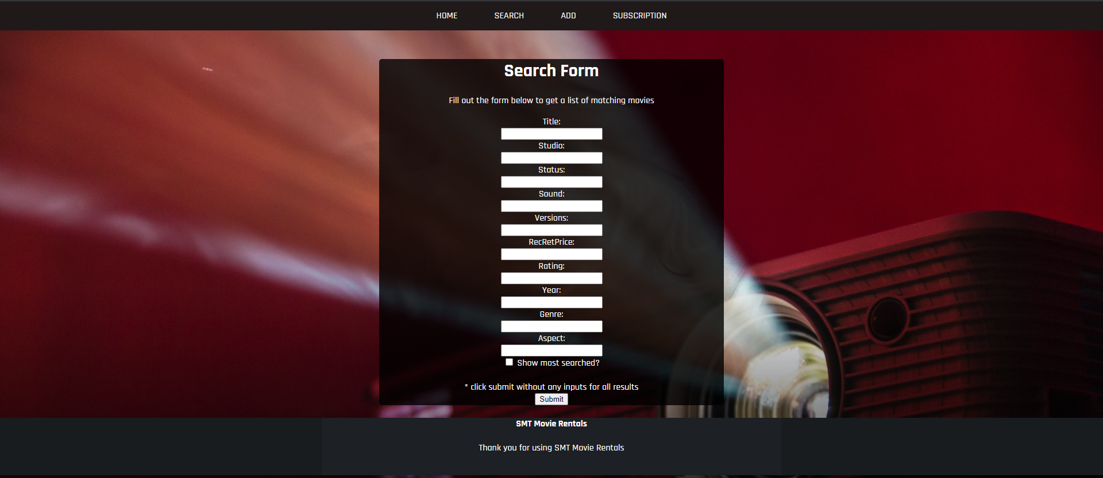

Add:  
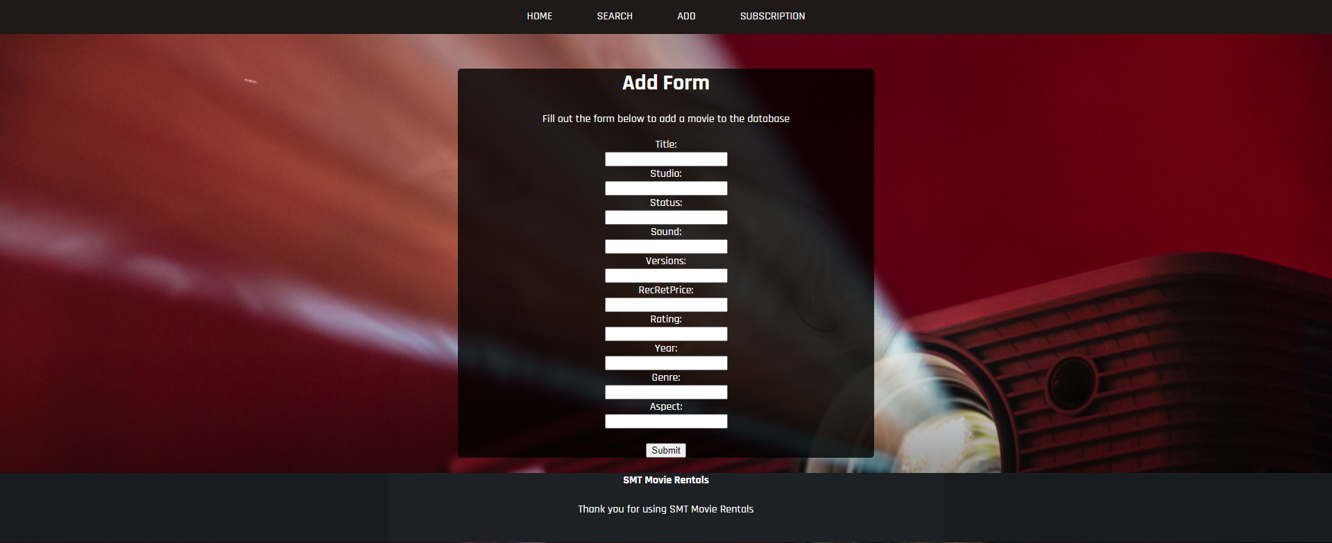

Subscription:  
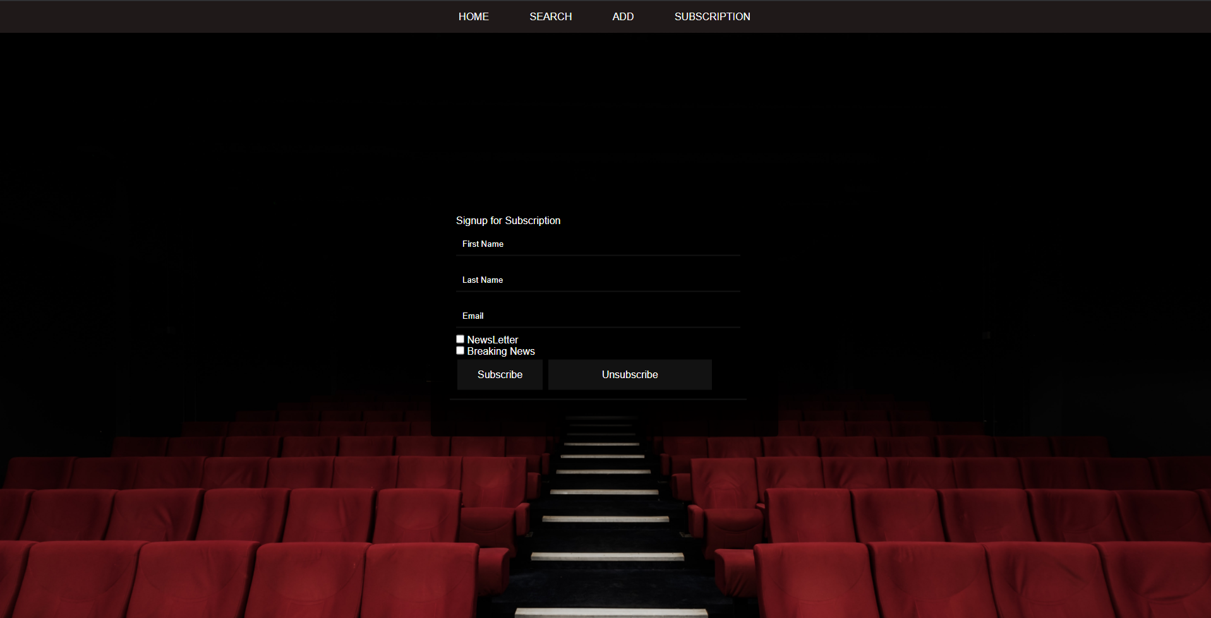

The UI Design is simple and is consistent across the entire website.

### Security

The website must be secure. If the website is not secure this could lead to devastating effects for the end user which may include having their personal email leaked to the public.  
To ensure that the website is secure, I used CITE’s quality control to identify problematic bits of code and to sniff out any problems with the website’s code. I figured the areas that would be prone to security faults would be the user inputs. E.g. name entering. These inputs must be filtered and sanitised before being entered into the database.  
Another security hole may be the SQL connection. We have chosen to use PDO, this is because it is more secure than MySQLi.

We have completed a test case document and code review to ensure that the website is as secure as possible.

We also used a PHPSniffer to detect any errors:  
<https://phpstan.org/>

Admin page:  
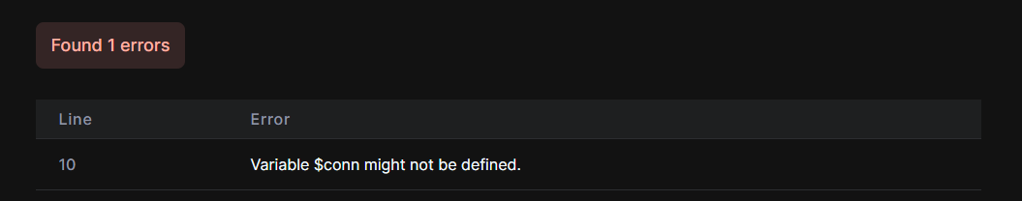

Adding Member:  
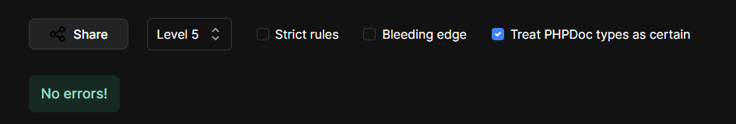

Admin Login:  
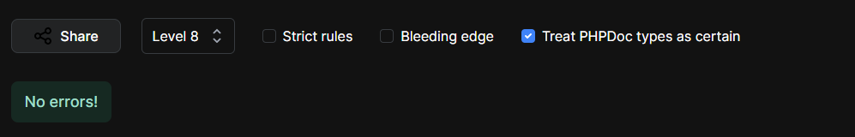

We reviewed these and made changes accordingly.

### Client Requirements

The website meets the client’s requirements.  
The requirements were that we must include a membership signup page with an option to sign up to newsletters. See below:   
We were also required to include an Admin page. See below:   
The admin page also required functionality to see all members and to delete them. See below:   
Finally, the website must also be able to send newsletters out to the members who have subscribed to them. See below:

Admin Page:  
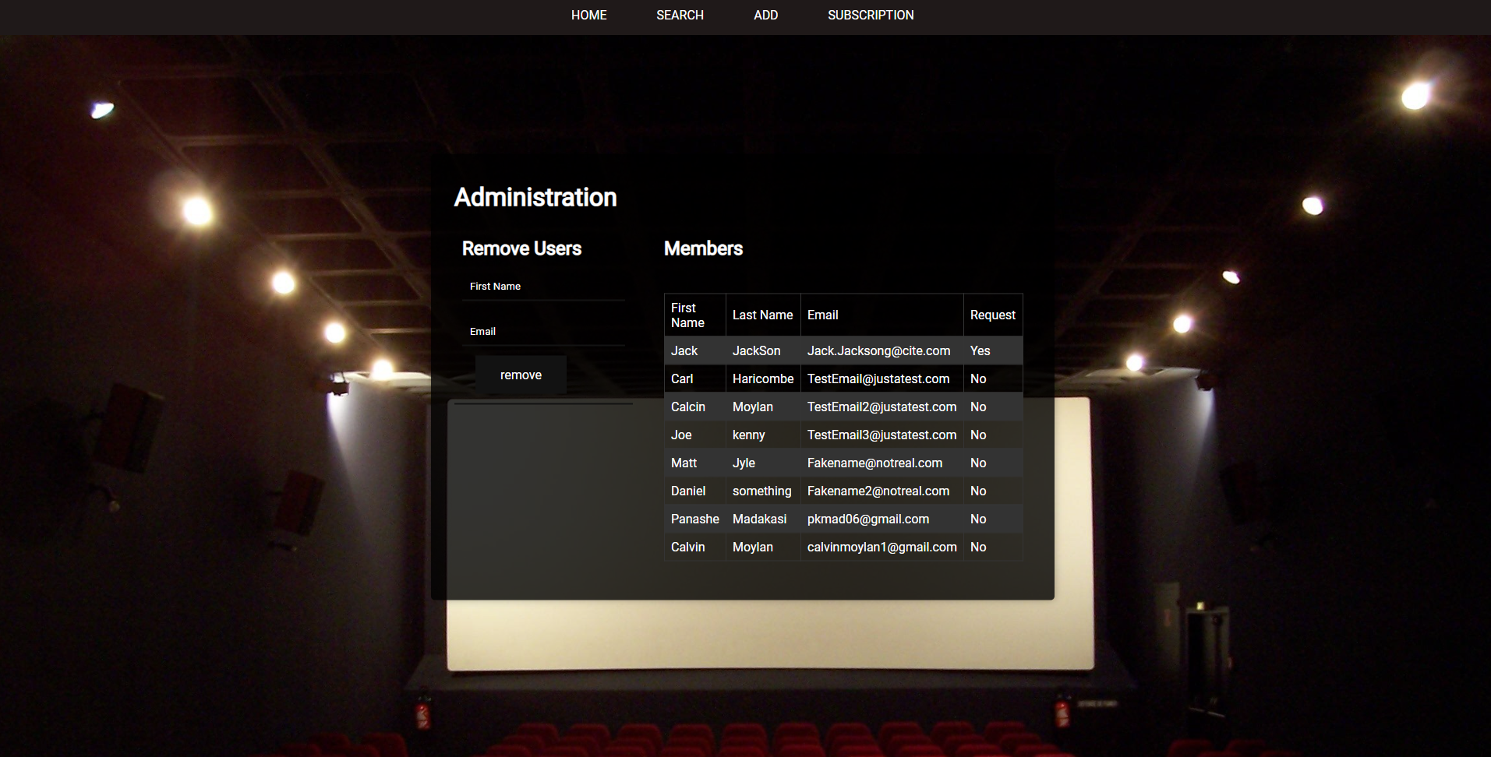

Sign Up Page:  
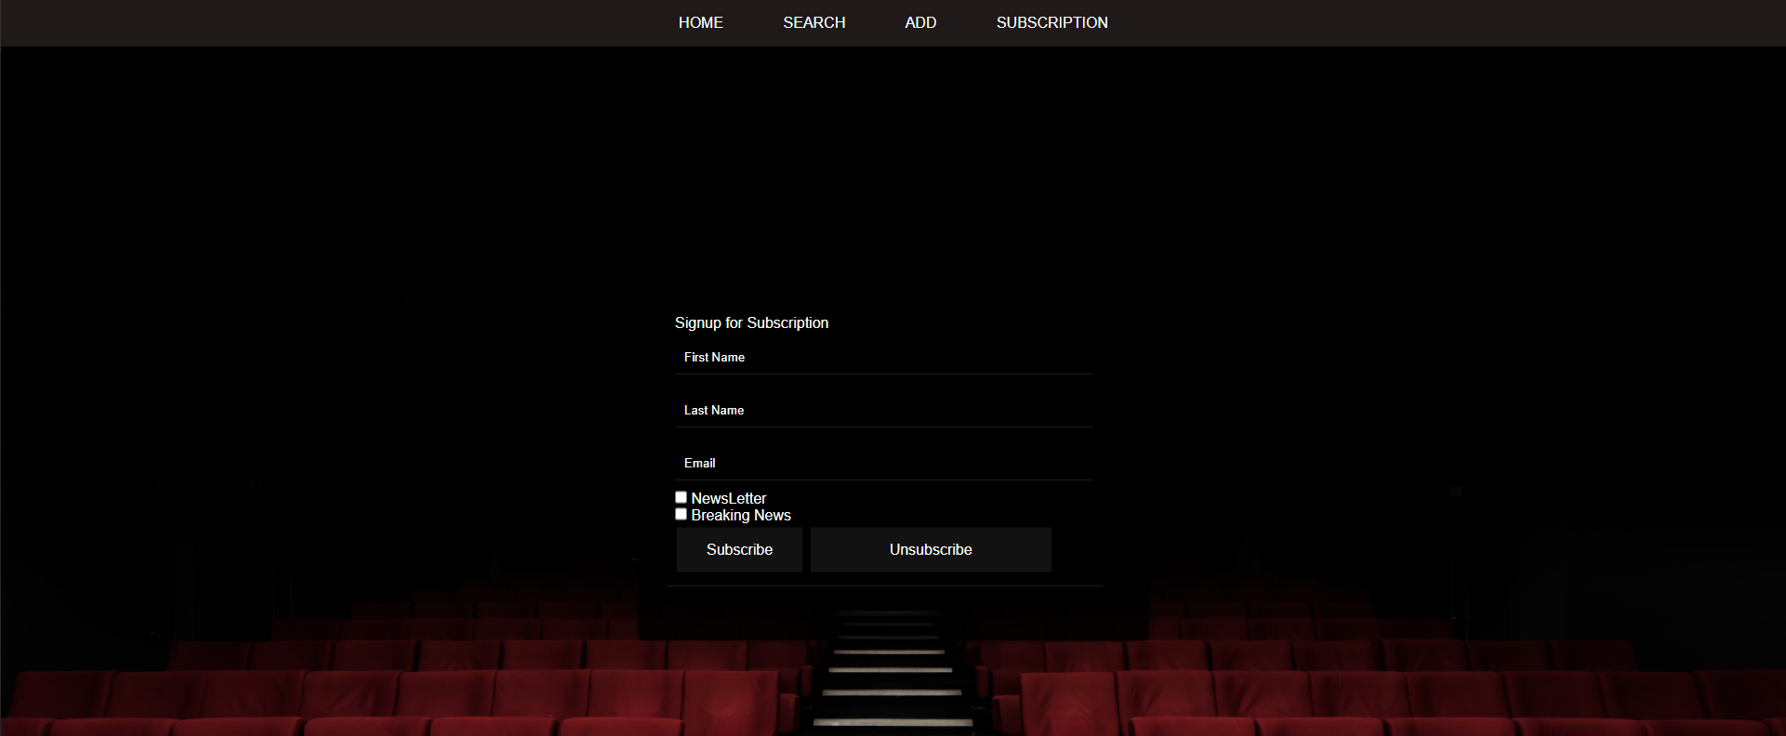

Admin Login page:  
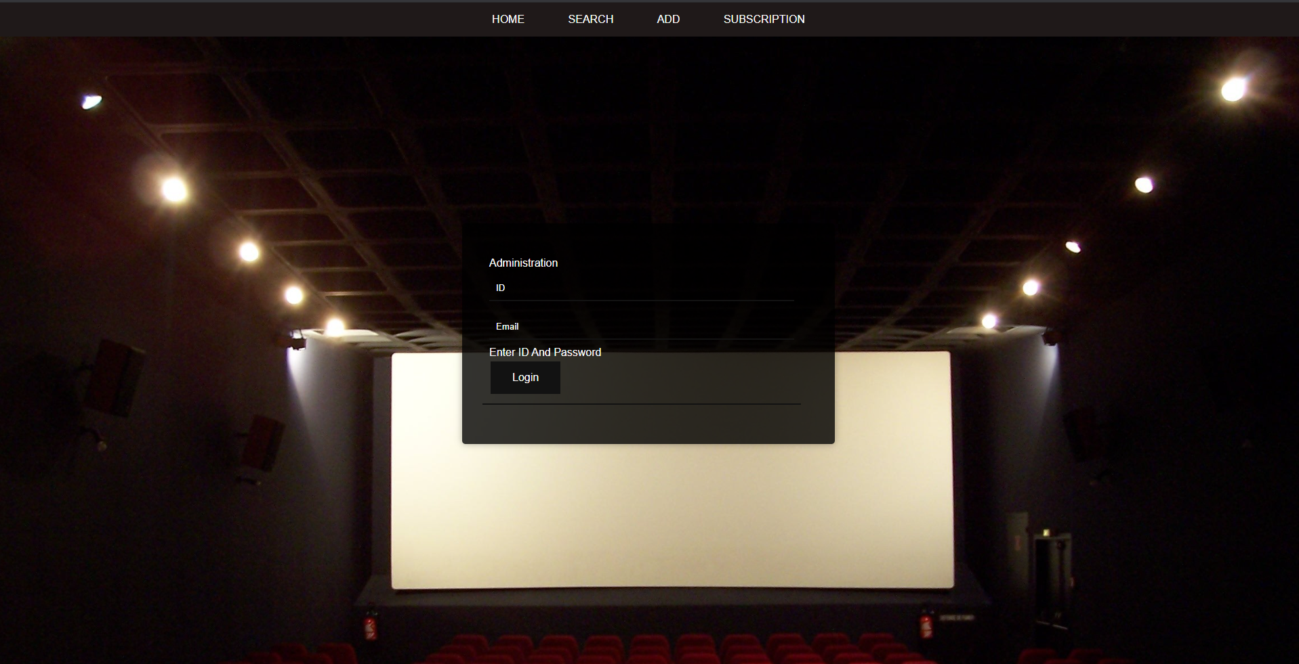

## Defect Tracking

There exists no defect tracking on the current version of the website. This means that we will have no way to see if there are any errors with the website and why it might be erroring. It may be useful to investigate adding some sort of defect tracker in the future.

## Risks

After conducting a review of the final product, I can conclude that the website is not prone to any sort of security risks. This is because all inputs from the user has been sanitised and all sensitive information is stored away from the users behind a database.

## Conclusion

Based on these findings, I can assure the client that the software written by Panashe for sprint two of the Rapid App Development meets all set requirements and it will meet the client’s satisfaction since the website has good performance, has simple and repetitive UI Design, Secure and the Client’s requirements has been met.